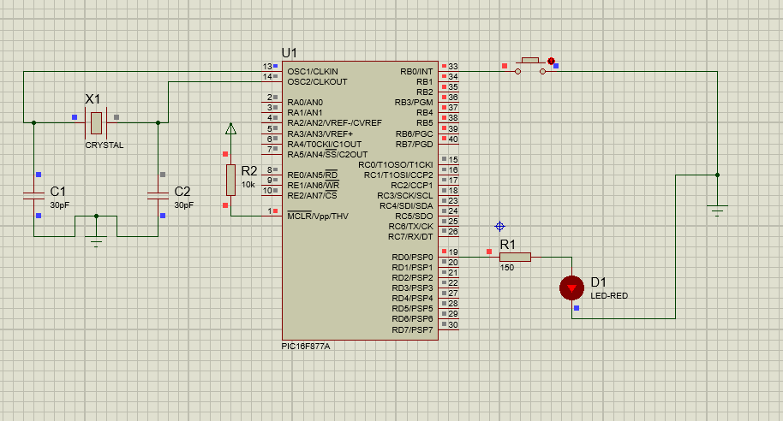#pragma config FOSC = HS

#pragma config WDTE = OFF

#pragma config PWRTE = OFF

#pragma config CP = OFF

#pragma config BOREN = ON

#pragma config CPD = OFF

#pragma config LVP = OFF

#pragma config WRT = OFF

#pragma config DEBUG = OFF

#include <xc.h>

#define _XTAL_FREQ 20000000

#define sw RB0 //switch input

#define LED RD0 //LED output

void main() {

TRISBbits.TRISB0 = 1; // configure RB0 as input

TRISDbits.TRISD0 = 0; // configure RD0 as output

OPTION_REGbits.nRBPU = 0;

unsigned int c = 0;

LED = 0;

while(1){

//pushbutton

if(!sw){

__delay_ms(50);

if(!sw){

c++;

__delay_ms(20);

if(c==2){

LED = !LED;

c=0;

while(!sw);

}

}

}

while(!sw){

__delay_ms(10);

}

}

}